Software Requirements Specification

October 29, 2014

Zephyr Management System

Submitted in partial fulfillment of the requirements of
CS F213 Object Oriented Programming

Submitted by:

Anurag Rai
R. Srinath
Deepika Ghodki
Shubham
Sumit Khaitan
Pratik Singhal
Jayanti Jain

Table of Contents

Table of Contents
1.0. Introduction
1.1. Purpose
1.2. Scope of Project
1.3. Overview of Document
2.0. Overall Description
2.1 System Environment
2.2 Functional Requirements Specification
2.2.1 Student Use Case
2.2.2 HR Use Case
2.2.3 Controls Use Case

3.0. Requirements Specification
3.1 External Interface Requirements
3.2 Functional Requirements
3.2.1 Login/Signup
3.2.2 Buy Passes
3.2.3 Order T-shirts
3.2.4 Vote
3.2.5 Submit Participation Details
3.2.6 Count Votes
3.2.7 Put up event Schedule
3.2.8 Update List Of Participants
3.2.9 Update Leaderboard

1.0. Introduction

1.1. Purpose
The purpose of this document is to present a detailed description of the Zephyr Management System. It will explain the purpose and features of the system, the interfaces of the system, what the system will do, the constraints under which it must operate and how the system will react to external stimuli. This document is intended for both the stakeholders and the developers of the system.

1.2. Scope of Project
This software system will be a Web Application for the inter-hostel festival: Zephyr. This system will be designed to maximize the organizers’ productivity by providing tools to assist in automating the various activities that are to be performed before and during the fest, which would otherwise have to be performed manually. This would increase the work efficiency of the organizers.
The system is designed to allow Zephyr Controls (Organizing Committee) to manage the various events taking place during the fest. It would allow the Controls to keep a track of all the participants registering for an event and notify them about the respective events automatically (as opposed to doing it manually). This system would facilitate the process of recording details of students who purchase t-shirts and passes for special nights. This information can then be directly used to carry out the financial transactions. This system would provide the feature of online voting for certain events which is performed using various social networking sites at present. In addition to this, it would update the scores and positions of hostels at regular intervals.

1.3. Overview of Document
The next chapter, the Overall Description section, of this document gives an overview of the functionality of the product. It describes the informal requirements and is used to establish a context for the technical requirements specification in the next chapter.
The third chapter, Requirements Specification section, of this document is written primarily for the developers and describes in technical terms the details of the functionality of the product.
Both sections of the document describe the same software product in its entirety, but are intended for different audiences and thus use different language.

2.0. Overall Description

2.1 System Environment
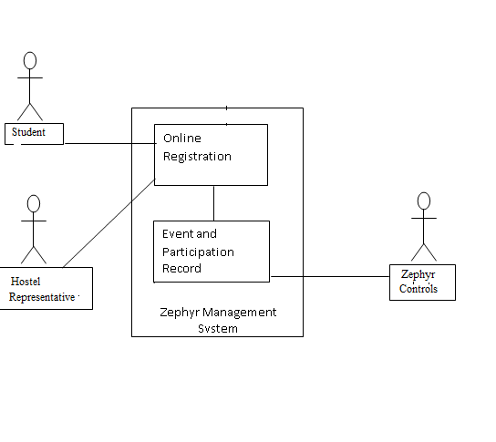
Figure 1 - System Environment

The Zephyr Management System has three active actors.
The Student, Hostel Representative, and the Zephyr Controls Member. Any student or hostel representative will be able to access the system after having created an account and choosing a password. The Controls accesses the entire system directly.

<< The division System into two component parts, the Online Registration and the Event and Participation Record based on the functions being performed by the actors. >>

2.2 Functional Requirements Specification
This section outlines the use cases for each of the actors. The student, HR, and Zephyr Controls are three actors. Out of them Zephyr Controls is Admin.

2.2.1 Student Use Case

Login/sign up
Diagram:
Student
Buy Passes
Order T-Shirts
Vote

Brief Description
The Student accesses the Web App by logging in or signing up (if first time). After which he/she can buy passes for special nights, order T-shirts and can poll for certain events.

2.2.2 HR Use Case

Diagram:
Hostel Representative
Login as HR
Submit Participation Details

Brief Description
The HR has to submit the details of participants from his hostel. For this HR has to login as HR and then submit the details.

2.2.3 Zephyr Controls Use Cases
The Editor has the following sets of use cases:
Count votes

Put up Events Schedule
Student
Submit Participation Details
Update list of Participants
Update Leader board

Brief Description
- Whenever someone poll controls need to count it.
- Zephyr controls need to put up schedule of all events so that every can know and participate accordingly.
- Zephyr controls will take the list of participants from HR of each hostel.
- Also as soon as HR of a hostel submits the list of participants from his respective hostel Zephyr controls should update the list of all the participants for an event.
- Whenever someone wins an event Zephyr Controls should update the leader board by increasing the points of the respective hostel.

3.0. Requirements Specification

3.1 External Interface Requirements
The only link to an external system is the link to the Student Database to verify the details of a student creating an account. This database would be used to The Student Database fields of interest to the Systems are student’s name, ID number, hostel number, contact number and email address.

3.2 Functional Requirements

3.2.1 Login/Signup
Use Case Name | Login/Signup or Login as HR
XRef | Section 2.2.1, 2.2.2
Trigger | The Student clicks on the Signup/ Login button
Precondition | The Student is connected to a network.
Basic Path | - If the student is visiting for the first time he will sign up to create an account.  - The student fill in the necessary details.  - If already has an account then the student will login using his ID and password.  - The System displays the home page.
Postcondition | The account is created.
Exception Paths | The Student may logout at any time.

3.2.2 Buy Passes
Use Case Name | Buy Passes
XRef | Section 2.2.1
Trigger | The user selects Buy Passes option.
Precondition | The user has logged in.
Basic Path | This use case takes the user to another page where the he can choose the events for which he wishes to buy a pass.
Postcondition | The record is updated.
Exception Paths | The attempt may be abandoned at any time.
Other | None

3.2.3 Order T-shirts
Use Case Name | Order T-shirts
XRef | Section 2.2.1
Trigger | The user selects T-shirts option.
Precondition | The user has to be logged in.
Basic Path | - This use case takes the user to another page where the he can choose the t-shirts he wishes to buy.
Postcondition | The list of students is updated.
Exception Paths | The Student may abandon the operation at any time.
Other | The author information includes the name and ID.

3.2.4 Vote
Use Case Name | Vote
XRef | Section 2.2.1
Trigger | The student has to select the polling option
Precondition | The student has logged in.
Basic Path | - This use case takes the user to another page where the he can cast his vote.
Postcondition | The response has been recorded and database updated.
Exception Paths | The Student may abandon the operation at any time.

3.2.5 Submit Participation Details
Use Case Name | Submit Participation Details
XRef | Sec 2.2.2, 2.2.3
Trigger | The HR selects the submit option.
Precondition | The HR has logged in.
Basic Path | - The HR submits the details of students who are participating.  - The system creates and presents an alphabetical list of people in the category.  - The Controls update the information.
Postcondition | The database has been updated.

3.2.6 Count Votes
Use Case Name | Count Votes
XRef | Section 2.2.3
Trigger | When a student selects vote.
Precondition | The students must submit the vote.
Basic Path | As soon as vote is submitted the system updates the count of the participant in whose favor the vote has been cast.
Postcondition | The database has been updated.
Other | The same user cannot vote twice.

3.2.7 Put Up Event Schedule
Use Case Name | Put Up Event Schedule
XRef | Section 2.2.3
Basic Path | - The system sends a notification to a participant before his event.
Postcondition | The notification must be sent.

3.2.8 Update List of Participants
Use Case Name | Update List of Participants
XRef | Section 2.2.3
Trigger | The Zephyr Controls selects the Update List option
Basic Path | - The editor updates the list based on the details received from the HR.
Alternative Paths | None.
Postcondition | List Updated.

3.2.9 Update Leaderboard
Use Case Name | Update Leaderboard
XRef | Section 2.2.3
Trigger | The Controls selects the update LeaderBoard option.
Basic Path | With the completion of an event the results are updated.
Alternative Paths | None.
Postcondition | The information has been displayed.

